** Question/Answer Booklet**

**Name: MEMO**

**PHYSICAL EDUCATION STUDIES YEAR 11 ATAR**

**Semester 1 Exam 2019**

**Time allowed for this paper**

Reading time before commencing work: 0 minutes

Working time for paper: 2 Hours 15 minutes

***To be provided by the candidate***

Standard items: pens, pencils, eraser, correction fluid, ruler, highlighter

**Important note to candidates**

No other items may be taken into the examination room. It is **your** responsibility to ensure that you do not have any unauthorised notes or other items of a non-personal nature in the examination room. If you have any unauthorised material with you, hand it to the supervisor **before** reading any further.

**Structure of paper:**

|  |  |  |  |
| --- | --- | --- | --- |
| Section | Number of questions available | Number of questions to be attempted | Marks available |
| **Section One:**  Multiple-Choice | 20 | 20 | 20 |
| **Section Two:**  Short Answer | 14 | 14 | 65 |
| **Section Three:**  Extended Answer | 3 | 2 | 20 |
|  |  |  | **105** |

Answer the fifteen **(15)** Multiple-Choice questions on the separate Multiple-Choice answer sheet provided.

**Multiple Choice (15 marks)**

1. Which of the following is not a characteristic of capillaries?

(a) Exchange carbon dioxide and oxygen.

(b) Have thin walls.

(c) Are microscopic.

(d) Have strong elastic walls.

2. The insertion point for the triceps muscle group is located on the:

(a) Ulna.

(b) Radius.

(c) Humerus.

(d) Scapula.

3. Extension of the knee joint involves:

(a) The hamstrings and gastrocnemius coming closer together.

(b) The hamstrings and gastrocnemius moving further apart.

(c) The tibialis anterior and gastrocnemius coming closer together.

(d) The tibialis anterior and gastrocnemius moving further apart.

4. Which of the following muscle groups are antagonistic pairs?

(a) Hamstrings, soleus.

(b) Pectorals, latissimus dorsi.

(c) Trapezius, biceps.

(d) Tibialis posterior, soleus.

5. Identify the joint movement performed by a swimmer’s shoulders during a backstroke race:

(a) Adduction.

(b) Flexion.

(c) Extension.

(d) Circumduction.

6. Which of the following statements about balance is TRUE?

(a) A lower centre of gravity and lower centre of mass decreases balance.

(b) A higher centre of gravity and higher centre of mass increases balance.

(c) A lower centre of mass and lower centre of gravity increases balance.

(d) A higher centre of mass and lower centre of gravity increases balance.

The picture below refers to Question **7 and 8.**

7. In order to achieve maximum acceleration, the athlete above needs to apply large amounts of force with each stride. This is an example of:

(a) Newton’s First Law of Motion.

(b) Newton’s Second Law of Motion.

(c) Newton’s Third Law of Motion.

(d) Newton’s Fourth Law of Motion.

8. Between the 30-40m mark of the race the athlete’s acceleration measures zero. This means he has:

(a) Decreased his speed.

(b) Increased his speed.

(c) Maintained his speed.

(d) Stopped running.

9. Sam’s swim coach calculates the average number of freestyle strokes she performs in a minute. This is a measure of Sam’s:

(a) Angular velocity.

(b) Angular acceleration.

(c) Angular speed.

(d) Angular distance.

10. By bending her knees on landing, Jane increases:

(a) Velocity.

(b) Inertia.

(c) Momentum.

(d) Impulse.

11. Long jump can be classified as a:

(a) Discrete skill.

(b) Continuous skill.

(c) Serial skill.

(d) Fine motor skill.

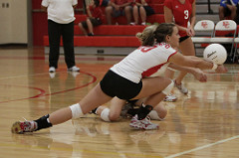12. In receiving a serve over the net, Phillipa decides to dig and moves accordingly. With reference to the Information Processing Model, this action is known as:

(a) Input.

(b) Output.

(c) Stimulus.

(d) Decision making.

13. Which of the following skills can be classified as the most discrete skill?

(a) 110m hurdles.

(b) Swimming 100m.

(c) Basketball free throw.

(d) Basketball lay-up.

14. Knowledge of results is an example of:

(a) Inherent feedback.

(b) Concurrent feedback.

(c) Extrinsic feedback.

(d) Intrinsic feedback.

15. During the second phase of learning, athletes should be encouraged to:

(a) Use their own feedback to detect and correct errors.

(b) Keep the learning environment exactly the same.

(c) Increase their reliance on augmented feedback to perfect the skill.

(d) Develop an understanding of how to perform the skill.

16. Which of the following is the best example of terminal feedback during a 100m swim race?

1. Hearing the crowd cheer when you lift your head to breathe.
2. Seeing the other swimmers next to you at the end of the first lap.
3. Feeling the movement of your arms with each stroke.
4. Seeing your time and final placing on the scoreboard.

17. Which of the following muscle groups are **not** antagonistic pairs?

1. Biceps, triceps.
2. Trapezius, deltoids.
3. Tibialis anterior, gastrocnemius.
4. Gastrocnemius, soleus.

18. To produce the movement in the picture below, the ballerina has performed:

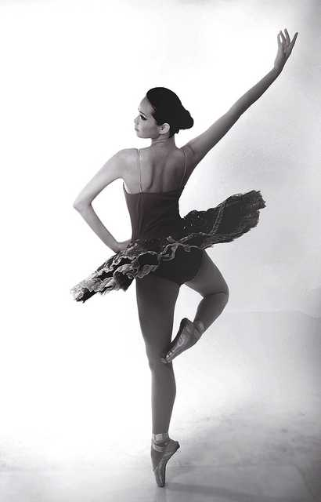

1. Plantar flexion of the ankle.
2. Dorsi flexion of the ankle.
3. Supination of the ankle.
4. Rotation of the ankle.

19. Which of the following muscles does not have its insertion point located on the humerus?

1. Deltoid.
2. Latissimus dorsi.
3. Biceps.
4. Pectoralis major.

20. Intrinsic feedback can also be known as:

1. Augmented feedback.
2. Extrinsic feedback.
3. Concurrent feedback.
4. Inherent feedback.

**Short Answer (60 marks)**

This section has **fifteen (15)** questions. Answer **all** questions. Write your answers in the spaces provided in this Question/Answer Booklet. Wherever possible, confine your answers to the line spaces provided. Use a blue or black pen (**not** pencil) for this section.

**Question 21 (3 marks)**

Identify the bones A through to C on the diagram below.

**C**

**B**

**A**

|  |  |  |
| --- | --- | --- |
| **A. Humerus** | **B. Ulna** | **C. Metacarpals** |

**Question 22 (4 marks)**

The body consists of three types of blood vessels: arteries, veins and capillaries. Compare and contrast **two (2)** characteristics of veins and arteries.

|  |  |
| --- | --- |
| Marks | Possible answers |
| 1 mark each characteristic | Characteristic 1  Arteries have thick elastic walls. Veins have thin, less elastic walls.  Characteristic 2  Arteries carry blood away from the heart. Veins carry blood to the heart.  Characteristic 3  Blood flow in arteries is created by heart beat/pulse. Blood flow in veins is created by muscular contraction.  Characteristic 4  Arteries typically carry blood rich in oxygen. Veins typically carry blood low in oxygen.  Characteristic 5  Arteries do not have valves. Veins contain valves.  NOTE: Answer must mention the characteristic from both arteries AND veins i.e. need to compare and contrast. |

**Question 23 (4 marks)**

**A B**

In reference to the picture above, identify:

|  |  |  |
| --- | --- | --- |
| 1. Joint movement (from A to B) | Abduction | 1 mark |
| 1. Agonist | Deltoid |
| 1. Origin (of agonist) | Clavicle or Scapula | 1 mark |
| 1. Insertion (of agonist) | Humerus |

**Question 24 (5 marks)**

Slow-twitch muscle fibres are also known as Type I muscle fibres. Briefly describe **three (3)** characteristics of slow-twitch fibres other than colour that differ from fast-twitch muscle fibres. Identify one activity suited to slow-twitch muscle fibres providing a reason for your answer.

|  |  |
| --- | --- |
| Marks | Possible answer |
| 1 mark for each correct answer | Any three of the following  *Slow-twitch muscle fibres:*   * Produce energy from the aerobic pathway * Have a slow contraction speed * Low force production * Have a high resistance to fatigue * Fibres are small in diameter * Have low PC stores * High amount of oxidative enzymes * High myoglobin content * High mitochondria density |
| 1 mark for activity  1 mark for reason | Identifies suitable activity – i.e. aerobic/endurance activity  Reasoning – links requirements of activity to fibre characteristic |

**Question 25 (6 marks)**

Identify the **muscles** A through to F on the diagram below.

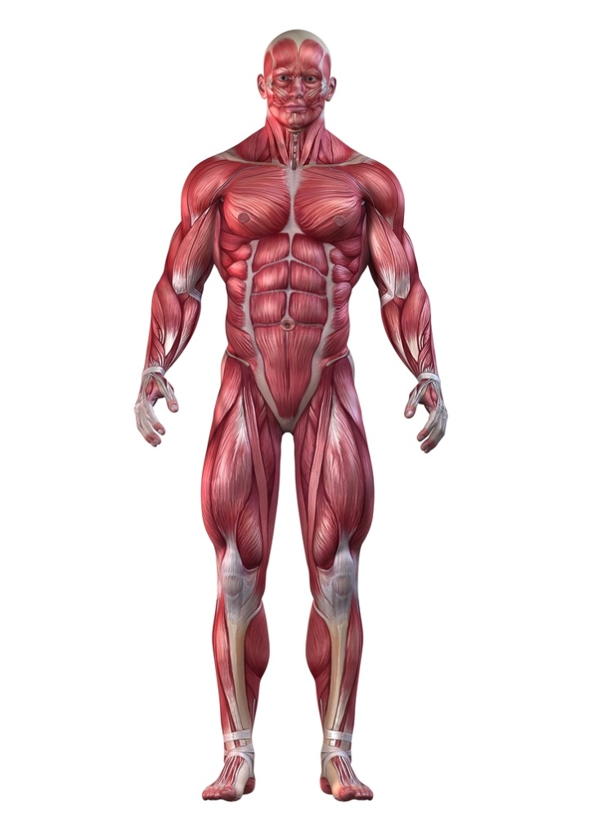

**A**

**B**

**C**

**D**

**E**

**F**

|  |  |  |
| --- | --- | --- |
| **A. Trapezius/sternomastoid** | **B. Deltoid** | **C. Biceps** |
| **D. Abdominals** | **E. Quadriceps** | **F. Tibialis Anterior** |

**Question 26 (7 marks)**

Motor skills can be classified according to a number of different factors, including the amount of muscle involvement and the effects of the environment.

(a) Explain the difference between gross and fine motor skills and provide a volleyball example of each. (3 marks)

|  |  |
| --- | --- |
| **Marks** | **Elaboration** |
| 1 mark  1 mark  1 mark | Explain difference – Gross motor skills involve large powerful movements using numerous, large muscle groups whereas fine motor skills involve delicate movements of small muscles (or similar)  Gross examples – choose from (or similar)   * Jump serve, spike, block, dive   Fine examples – choose from (or similar)   * Stationary set, net tip, stationary dig |

(b)(4 marks)

Place the following activities (A, B, C, D) on the continuum below.

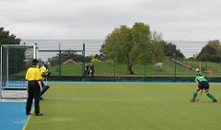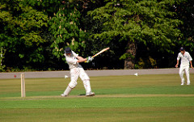

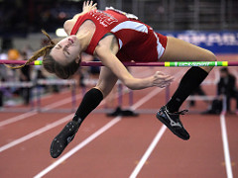

1. Cricket stroke **B**. Penalty stroke (green shirt)

**C**. High jump **D**. Surfing

Penalty stroke

Cricket stroke

Surfing

High jump

**OPEN CLOSED**

**2 marks for correct answers**

**Question 27 (4 marks)**

The image below shows a hockey goal keeper defending a penalty corner. The attacking team passes the ball to the top of the circle, where a forward will hit or flick the ball towards the goal. The success of the goal keeper will depend on how efficiently he can progress through the four phases of information processing.

1 mark for naming the phase, 1 mark for explanation (4 mark)

Phase 1 – Input

Explanation

Goal keeper uses senses of sight and sound to identify the cues in the environment

Phase 2 Response Identification or Decision Making or processing

Explanation

Goal keeper interprets all cues (e.g. speed and direction of shot). Brain prepares an appropriate response based on cues

Phase 4 – Feedback

Explanation

Goal keeper receives information about his performance (ie ball goes in goal or is saved)

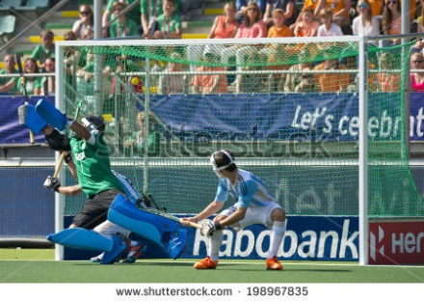

Phase 3 Response or Output

Explanation

Goal keeper makes a movement in response to the cues (eg moves hands above head to make high save)

**Question 28 (4 marks)**

Explain **two (2)** differences in skill learning among children and their implication for coaching.

|  |  |
| --- | --- |
| Marks | Possible answer |
| 1 mark for differences (max. 2)  1 mark for implication linked to differences (max. 2) | **Differences**  *Possible responses:*   * Lack fine motor skills * Varied growth rates among similar age groups * Coordination difficulties due to growth spurts * Lower tolerance of hot/cold conditions * Different body proportions   **Implications**  *Possible responses (need to link to Differences):*   * Using lighter or modified equipment * May need to have varied activities for the group, different skill levels * Provide time adequate time for learning * Focus on skill acquisition and development * Modify activities in adverse conditions |

**Question 29 (4 marks)**

Feedback can be provided in various forms. Briefly explain **two (2)** purposes of providing feedback to athletes.

|  |  |
| --- | --- |
| Marks | Possible answer |
| 1 mark for purpose (max. 2)  1 mark for explanation (max. 2) | *Any two of the following:*  **Feedback to modify performance**   * Providing constructive feedback about positive aspects and areas to improve   **Feedback for motivation**   * Providing positive feedback to support, encourage, recognise athletes and/or their efforts   **Feedback to reinforce**   * Reinforce what has been learnt so that athletes repeat what is required |

**Question 30 (3 marks)**

Define the terms positive, negative and zero acceleration and provide an example of each during a 200-metre freestyle swim.

|  |  |
| --- | --- |
| **Marks** | **Elaboration** |
| 1 mark – must have both defn and example | *Positive Acceleration*  Definition – the moving body is increasing in velocity (or similar)  Example – Leaving the blocks, first 2-5 strokes before reaching top speed |
| 1 mark – must have both defn and example | *Negative Acceleration*  Definition – the moving body is decreasing in velocity (or similar)  Example – Touching the wall before tumble-turn or end of race or final stages of race when fatigued |
| 1 mark – must have both defn and example | *Zero Acceleration*  Definition – the moving body is maintaining a constant velocity (or similar)  Example – Approx10 metre mark to the 45-metre mark of each lap (once top speed has been reached and before slowing for tumble-turn) |

**Question 31 (8 marks)**

1. Other than gravity, there are several factors that will impact the path of projectiles. Define and apply **three (3)** factors that will affect the path of a shot put. (6 marks)

|  |  |
| --- | --- |
| Marks | Possible answer |
| 1 mark for description (max. of 3)  1 mark for application (max. of 3) | **Height of release**   * The difference between the release height and the landing height * Has a higher release height than landing position   **Angle of release**   * The angle at which the projectile (shot put) is released/thrown * Should be released at an angle less than 45⁰   **Velocity of release**   * The velocity of the projectile/shot put at the point of release * Correct sequencing and timing of body parts applied in the direction of the throw * Velocity maximised to achieve maximum distance |

1. To achieve maximum horizontal distance, a projectile should be released at a 45⁰ angle. Other than shot put, explain one sporting example where it is necessary to have an angle greater than 45⁰, and one example where it is necessary to have an angle less than 45⁰.

(2 marks)

|  |  |
| --- | --- |
| Marks | Possible answer |
| 1 mark  1 mark | **Greater than 45⁰**   * Appropriate example where landing height is higher than release point e.g. basketball free throw   **Less than 45⁰**   * Appropriate example where landing height is lower than release point e.g. hammer throw |

**Question 32 (3 marks)**

When teeing off, a golfer must maximise the speed of the club to achieve maximum velocity onto the ball. Identify and explain the coordination of movement the golfer would utilise to achieve maximum club speed.

|  |  |
| --- | --- |
| Marks | Possible answer |
| 1 mark  1 mark  1 mark | Sequential movement  Identifies movement of body parts in a sequence with appropriate timing, to transfer momentum to achieve velocity  Application to golf swing |

**Question 33 (6 marks)**

Using specific examples, identify **three (3)** types of motion in the picture below.

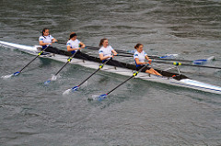

|  |  |
| --- | --- |
| Marks | Possible answer |
| 1 mark | **Linear motion**  Any suitable example of movement in a straight line e.g. the boat |
| 1 mark | **Angular motion**  Any suitable example of movement around an axis e.g. shoulders |
| 1 mark | **General motion**  Any suitable example of movement combing both linear and angular motion e.g. the rower’s body |

**Question 34 (4 marks)**

Using examples, explain **two (2)** types of balance a gymnast may display during a floor routine.

|  |  |
| --- | --- |
| Marks | Possible answer |
| 1 mark  1 mark | **Static balance**  Ability to maintain equilibrium while stationary  Example – Handstand or suitable example |
| 1 mark  1 mark | **Dynamic balance**  Ability to maintain equilibrium while moving  Example – performing a series of somersaults or suitable example |

**Extended Answer (20 marks)**

This section contains three (3) questions. **You must answer two (2) of these questions.** Write your answer in the spaces provided.

Spare pages are included at the end of this booklet. They can be used for planning your responses and/or additional space if required to continue an answer.

* Planning: if you use the spare pages for planning, indicate this clearly at the top of the page.
* Continuing an answer: If you need to use the space to continue an answer, indicate in the original space where the answer is continued, i.e. give the page number. Fill in the number of the question that you are continuing to answer at the top of the page.

**Question 35 (10 marks)**

The three golfers pictured below are in different phases of their golf career. The child pictured on the left is attempting to hit a golf ball for the first time, the recreational golfer pictured in the middle is working to improve his game, while the adult pictured to the right is playing in a professional tournament.

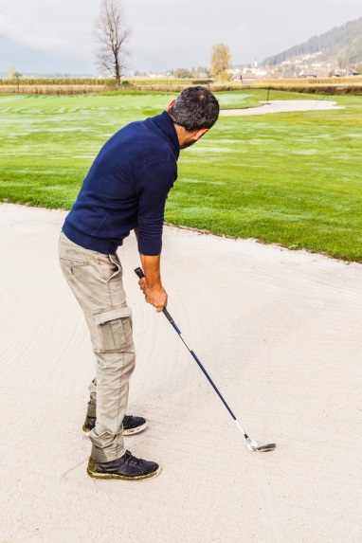

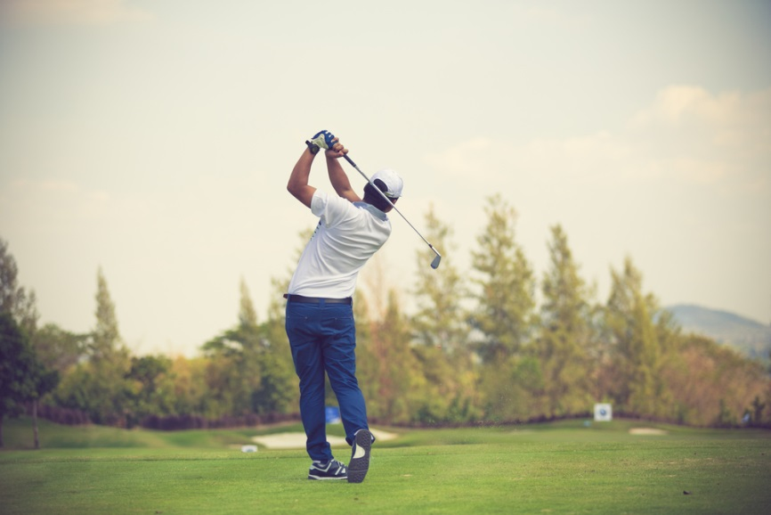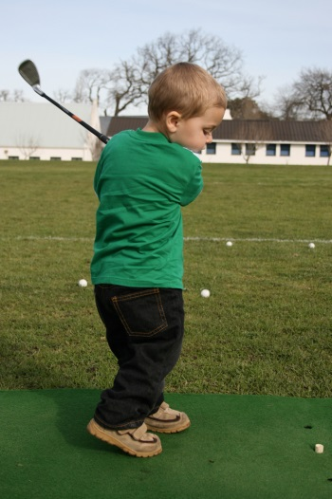

According to the Fitts and Posner model of skill learning, explain the three phases a golfer would move through as they progress from beginner level through to professional. In your response, identify the performance characteristics and type of feedback the learner would require in each phase to maximise their skill learning. Also identify the phase you would expect the golfer to spend the shortest amount of time in.

|  |  |
| --- | --- |
| **Marks** | **Elaboration** |
| 1 mark | Identifies ‘cognitive phase’ as the phase expected to spend the shortest amount of time in |
| 3 marks max  1 mark  1 mark  1 mark | *Cognitive Phase*  Explanation – Phase in which the learner has little understanding of the skill and how to perform it  Characteristics – Inconsistent/erratic performance, many large-scale errors  Feedback required – concurrent, verbal and non-verbal feedback required to correct errors |
| 3 marks max  1 mark  1 mark  1 mark | *Associative Phase*  Explanation – Phase in which the learner understands how to complete the skill and is practicing to improve their performance  Characteristics – Learner makes less errors and performance is becoming more efficient and consistent  Feedback required – more specific augmented feedback or learner begins to use internal feedback to recognise their own errors |
| 3 marks max  1 mark  1 mark  1 mark | *Autonomous Phase*  Explanation – Phase in which the learner has mastered the skill  Characteristics – Able to complete the skill fluently, accurately and consistently with minimal errors and high levels of speed/power  Feedback required – augmented feedback directed towards strategy rather than skill learning or internal feedback utilised to correct own errors |

**Question 36 (10 marks)**

From the point of inhalation, describe the mechanics of breathing, including pressure change and flow of oxygen through the cardiorespiratory system to supply oxygen to the working muscle/s.

|  |  |
| --- | --- |
| Marks | Possible answer |
| 1 mark for identification of 8 **structures**  must appear in correct order  2 marks for pressure change | * **Diaphragm** contracts/moves downward to increase space available * **Ribs** rise to increase space available * Oxygen enters the body via the **mouth/nose** * **Lungs** expand/fill with air. Oxygen travels down through the **pharynx, larynx** and **trachea** into the **bronchi** and **bronchioles**. * Gas exchange occurs at the **alveoli** * *Pressure change* – Oxygen pressure in the alveoli is higher than that in the surrounding capillary. As a result, oxygen will move from an area of high pressure to an area of low pressure i.e. from the alveoli to the capillary, via diffusion. * Oxygen returns to the heart via the **pulmonary veins**. * Blood enters the **left atrium**, * Followed by the **left ventricle**. * Blood exits the heart via the **aorta** to travel to the **working muscles** to exchange oxygen, carbon dioxide and waste products |

**Question 37 (10 marks)**

Swimmers may use different stances when on the starting blocks at the beginning of a race. Identify which swimmer (A or B) would have the greater stability and describe Newton’s Three Laws of Motion in relation to the swimmer in picture B.

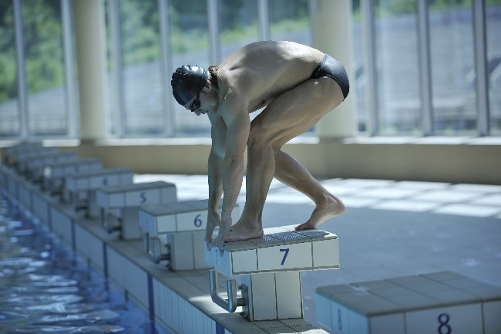

**A B**

|  |  |
| --- | --- |
| Marks | Possible answer |
| 1 mark | **Swimmer B** |
| 1 mark for description  2 marks for application | **Newton’s First Law of Motion**  An object remains at rest, or continues its path, until acted upon by an external force (or similar).  Application – swimmer remain on blocks until external force is applied (by himself), or other relevant example |
| 1 mark for description  2 marks for application | **Newton’s Second Law of Motion**  An object’s acceleration is proportionate to the external force applied (or similar)  An object’s acceleration is inversely proportionate to it mass (or similar)  Application – the more force the swimmer applies to the blocks, the greater the acceleration at the start, or other relevant example. |
| 1 mark for description  2 marks for application | **Newton’s Third Law of Motion**  For every action there is an equal and opposite reaction  Application – the swimmer applies force while standing on the blocks and the blocks exert a force against the swimmer, or other relevant example |